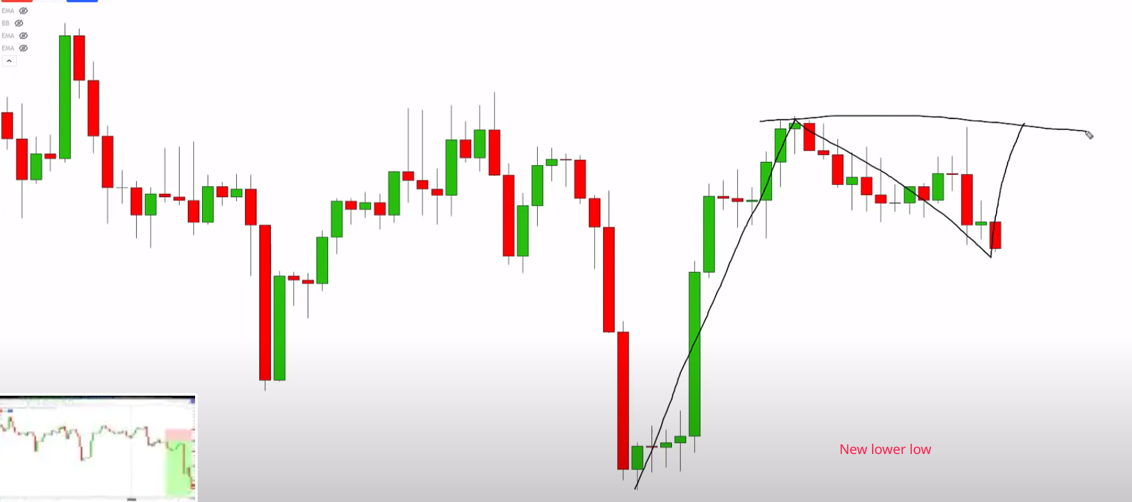

First top

Previous lows

NOTE: Any **candle color** can be used when defining **double tops** in both market directions.

**Objective rules for defining a double tops. 4h,1h,15min or 5min chart is good for day trading.**

**1. A**fter we make a new lower low compared to our previous lows, we then push up this is considered our first top.

**1a**. As soon as i see this first top made, i put a horizontal line at the top of the bodies of that first top.

**1b.** And a horizontal line at the top of the of the wick of that same candle.

**1.c** The little area between **top and body of the wick** is as my **termination point.**

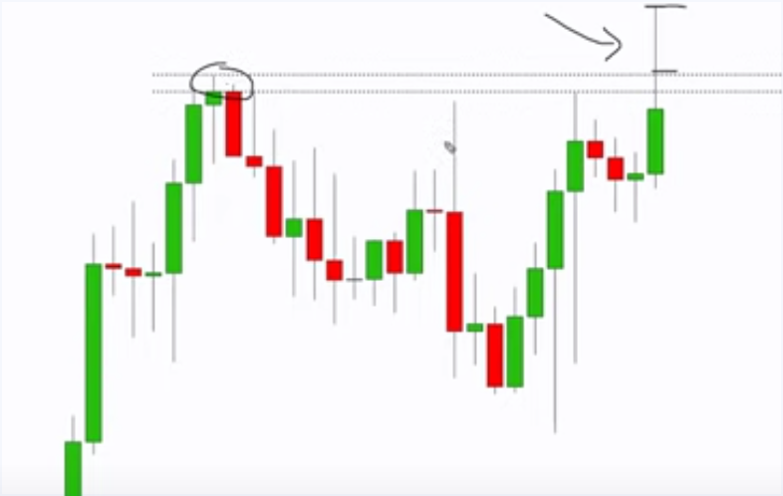

**Implementing double tops rules.**

1. I want to see price **pushed up** and at least touch my **termination zone,** that can be with just the **wick of a candle or**  the **body of a candle closing inside of my zone and a wick pushing above it that all is completely** valid.

What i do not want to see is a push-up and **then a candle close outside of my termination zone** and in other words i don't want to see a **candle close above the previous high.**

I'm waiting on a little bit of **extra confirmation with this strategy** here what did i say earlier i said that **we could have a wick go above this area** right this actually shows me **a really good sign of rejection from our** first top **and we still have a valid double top.**

**A**t this point i am actually waiting for the market to break the neckline with this specific strategy here would be the neckline is just the middle of a double top.

I want to see a candle close below the neckline of the double top so now that i have a valid double top, i need to see the market break through the neckline.

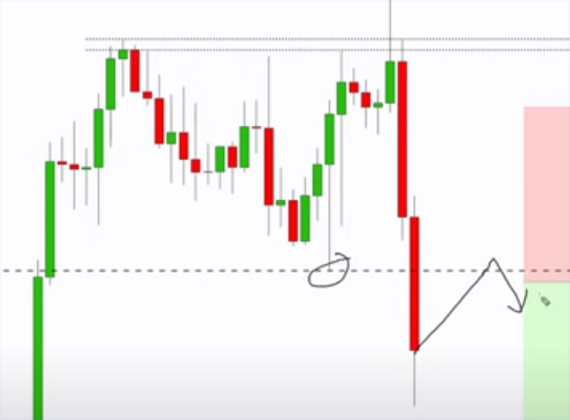

**Neckline broken**, market

pushes **Down**, then **up** touches the **neckline**, then

**Selling pressure Red candle appears.**

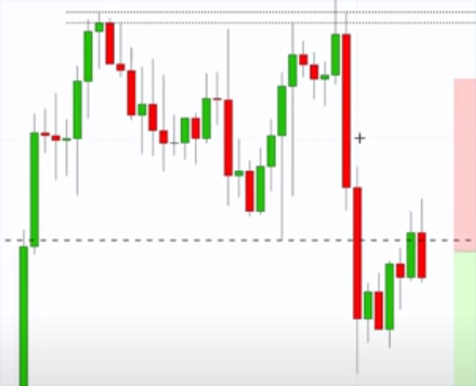

Selling pressure.

Red candle right.

**Complete Rules summary**

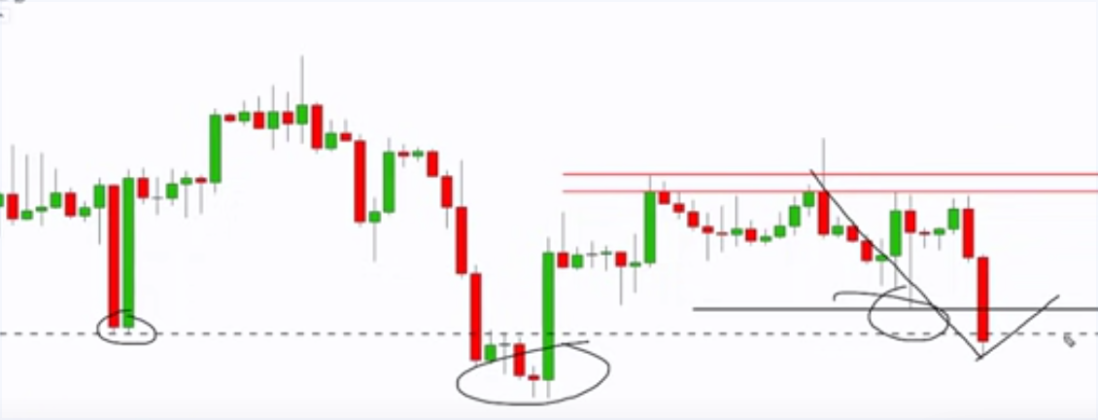

1. First condition is the market must make a **new lower low**.

2. Part of the entry, i want to see a **double top created.** We have definded rules for that.

1a. I want to see a **push up,** i want to see **one top,** i want to see a **pullback** and then **another top**

3. I need the market to **break below the neckline** and close below it.

4. I need the market to **pull back at least touch the neckline with a candle**

and then **i need selling pressure and selling pressure** for me is just a **red candle with this strategy** so all of that needs to come together before i can enter the trade.

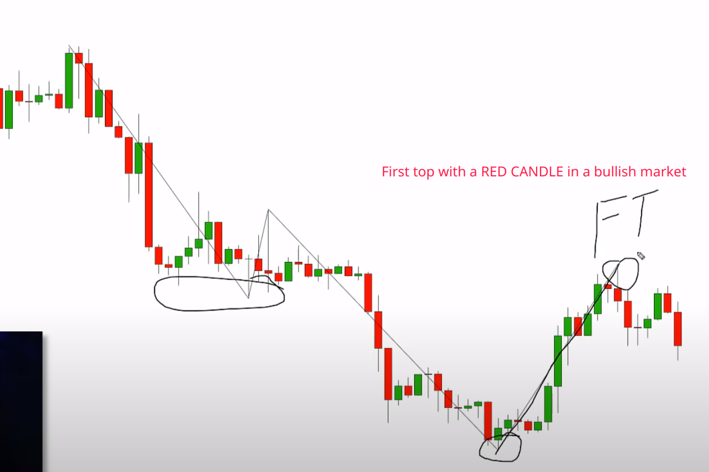

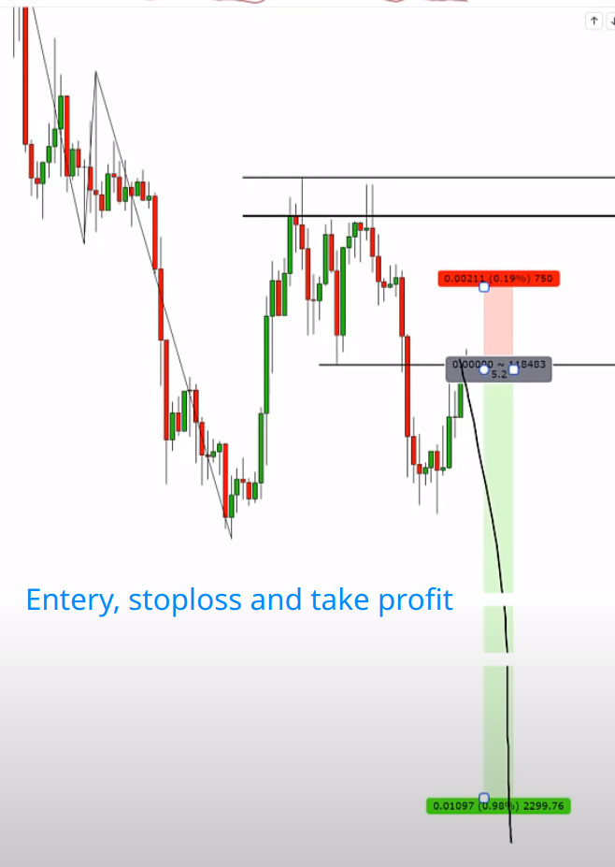The entry candle is the selling pressure candle which in this case is the RED DOJI CANDLE

